
Welcome to the GLINT tutorial!
As molecular glues become increasingly important in targeted protein degradation and the regulation of protein–protein interactions, efficiently identifying potential targets, characterizing interface features, and optimizing candidate molecules has emerged as a key challenge in computational biology and drug design. GLINT was developed in this context as an integrated analysis toolkit, aiming to provide researchers with a systematic solution spanning from target discovery to molecular optimization.
GLINT integrates several core functional modules, including:
- Target Discovery: for identifying potential binding sites and detecting G-motif features
- Hit Identification: for pocket detection and docking analysis
- Ternary Evaluation: for interface scoring and neo-epitope mapping
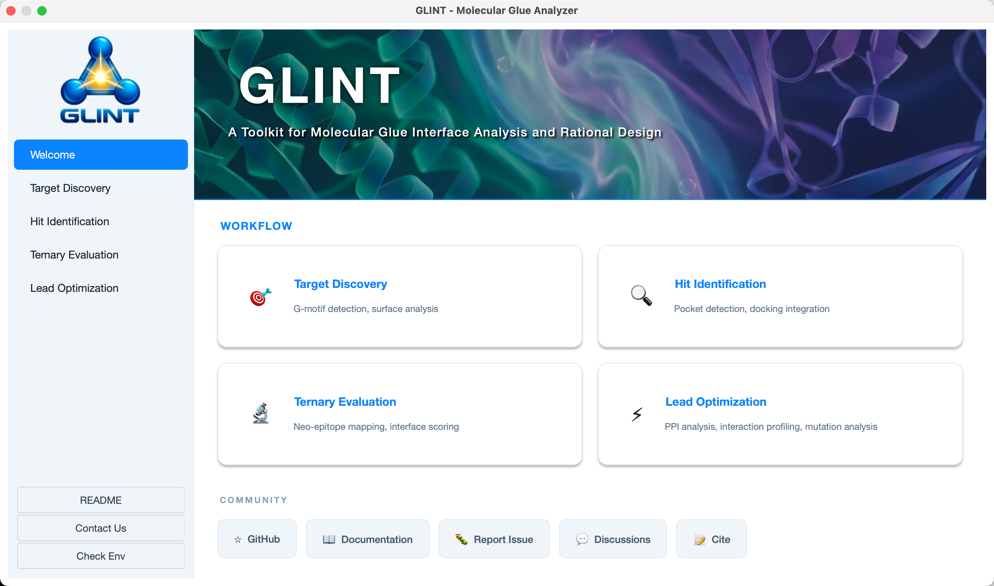
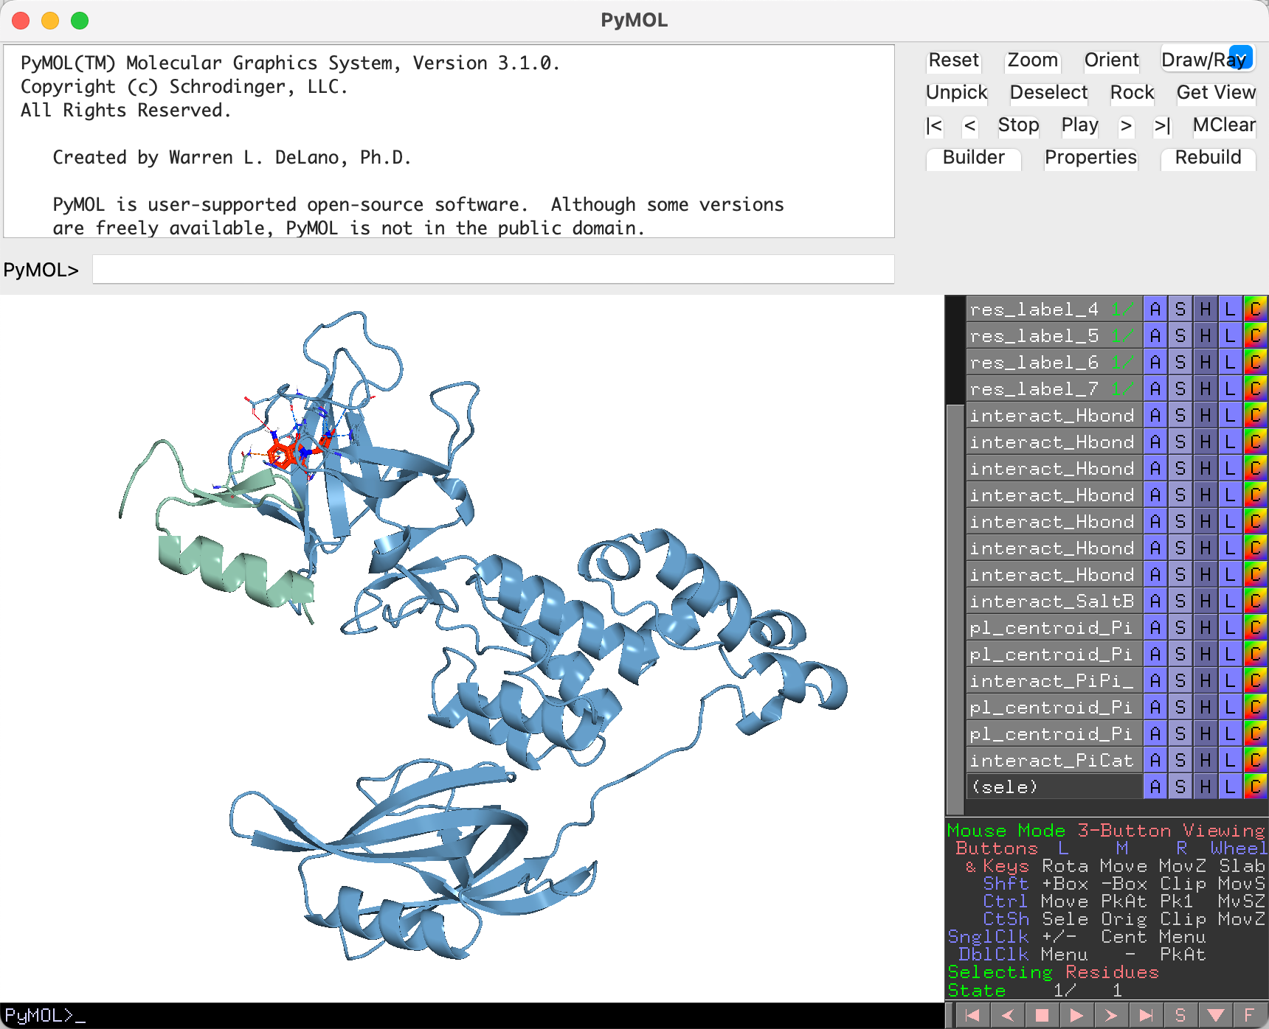
- Lead Optimization: for interaction profiling and mutation analysis

This tutorial starts with basic operations and gradually guides you through the workflow of using GLINT. Through step-by-step examples, it demonstrates how to complete a full molecular glue design and analysis task. Whether you are new to this field or looking to improve your analysis efficiency, this guide will help you get started quickly.

Chapter 1 Installation guide
Welcome to the official GLINT installation guide. This chapter covers the system requirements, pre-requisites, and step-by-step installation procedures for macOS, Windows, and Linux.

System Requirements
Table 1. Minimum System Requirements
Component | Requirement
Operating System | macOS 10.14+, Windows 10/11, Linux (Ubuntu 20.04+)
Processor | 64-bit processor
RAM | 8 GB minimum (16 GB recommended
Disk Space | 5 GB free space
Software | Miniconda or Anaconda, Python3

1.2 Pre-requisites: Installing Conda
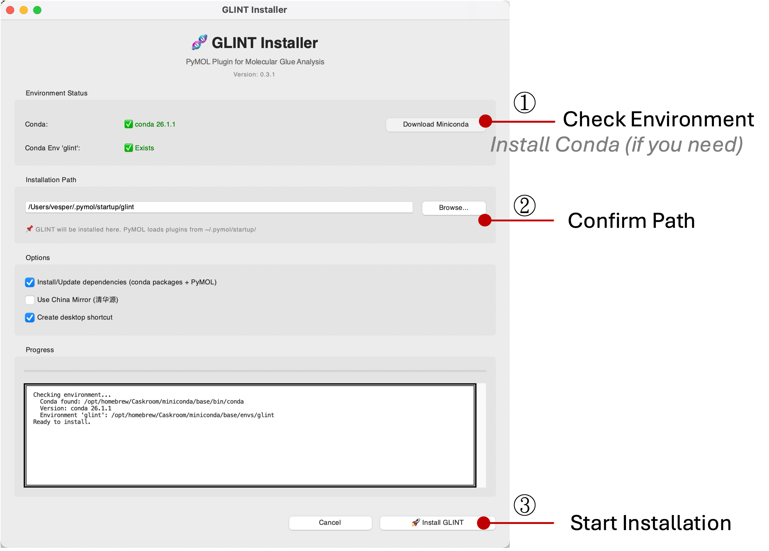
Figure 1. GLINT Installer interface with key steps highlighted
Table 2. Installation Paths
Platform | Path
MacOS / Linux | ~/.pymol/startup/glint
Windows | C:\Users\<Username>\.pymol\startup\glint

1.3 Optional Dependencies
1.3.1 HADDOCK3 (Protein-Protein Docking)
HADDOCK3 is required for ternary complex modeling. If the system has the necessary build tools, it is typically installed automatically by the installer or setup script. If not, it can be installed manually using the command pip install haddock3. On Windows, it is recommended to use the HADDOCK Web Server instead of local installation: https://wenmr.science.uu.nl/haddock2.4/
1.3.2 APBS (Electrostatic Analysis)
APBS is used for calculating surface electrostatics. On macOS, it is usually bundled with the GUI installer; otherwise, it can be installed via Homebrew using brew install brewsci/bio/apbs. On Windows, it should be downloaded from Poisson-Boltzmann.org.
1.3.3 Missing Dependencies
If any dependencies are missing, you can rerun the installer to attempt automatic resolution. Alternatively, required packages can be installed manually using Conda with the command conda install <package_name>.

Chapter 2 Target Discovery
This chapter introduces the Target Discovery functionality of GLINT, designed for molecular glue target identification. It includes three core modules:
- G-Motif Detection
- Protein Surface Analysis
- Surface Similarity & Complementarity Analysis
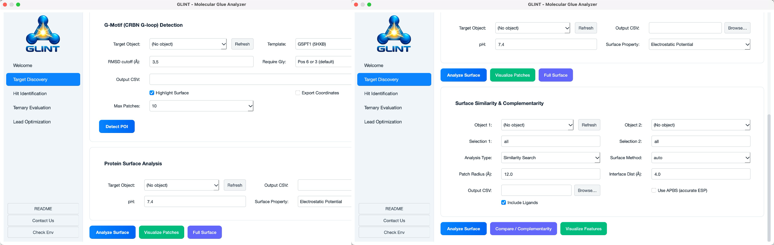
Figure 2. Target Discovery functionality of GLINT.

2.1 G-Motif Detection
G-Motif Detection is designed to identify potential G-loop domains in CRBN molecular glue substrate proteins. The G-loop is an 8-residue structural motif whose conformation enables binding to the CRBN E3 ligase, forming a key interface in molecular glue–induced ternary complexes.
To address the reliance of CRBN molecular glues on local loop conformations of substrates, we developed a structure-based G-loop template matching module. This module extracts Cα coordinates of consecutive 8-residue segments from the target protein and aligns them to known G-loop templates derived from validated substrates. Structural similarity is evaluated via geometric superposition and RMSD calculation. Compared to sequence motif searches, this approach emphasizes structural equivalence, making it more suitable for identifying candidates with low sequence homology but conserved conformations.
The implementation supports multiple templates and alias mappings, and is robust to insertion codes, alternate conformations, and inconsistencies in PDB residue numbering for CRBN interface regions. A default RMSD cutoff of 3.5 Å is applied, with an optional constraint requiring glycine at position 6. The output is fully compatible with downstream residue-highlighting tools and can be directly visualized in PyMOL, enabling an integrated “search–locate–interpret” workflow.
Core Algorithm
RMSD-based structural matching: align the Cα atoms of 8-residue segments in the target protein to known G-loop templates and evaluate conformational similarity using RMSD.
Table 3. Templates of G-Motif
Name | PDB ID | Residue Range
GSPT1 | 5HXB | A:570–577
CK1α | 5FQD | C:35–42

2.1.1 Workflow
Load Structure:
Load the target protein structure in PyMOL (PDB file or existing object).
Open Target Discovery Panel:
Click GLINT → Target Discovery tab.
Select Target Object:
- Choose the object from the “Target Object” dropdown
- Click “refresh” to update the list
Select Template:
- GSPT1 (5HXB): for GSPT1-type G-loop detection
- CK1α (5FQD): for CK1α-type G-loop detection
- From Selection: use currently selected residues in PyMOL as a custom template
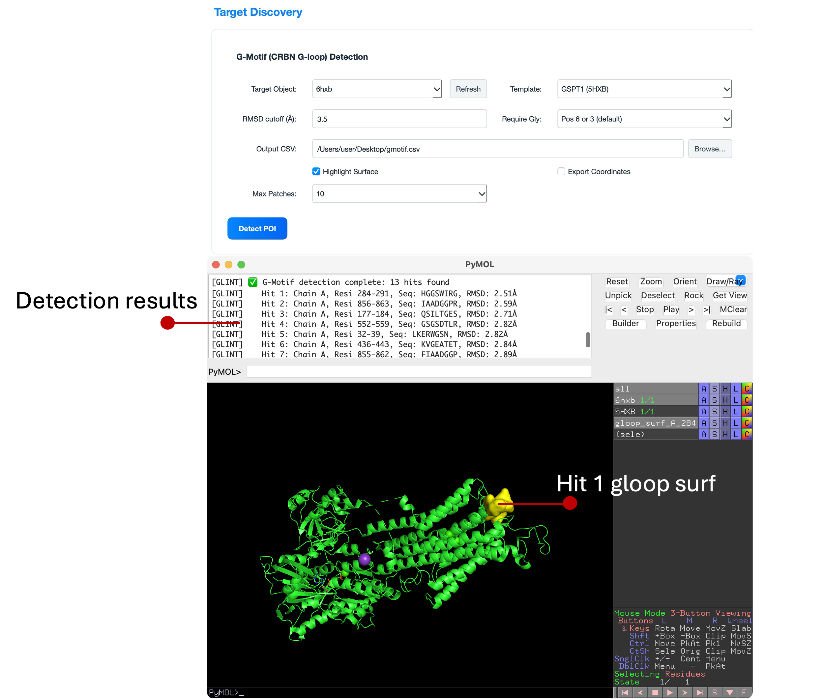
Figure 3. G-Motif (CRBN G-loop) detection workflow and results in GLINT.
The top panel shows the Target Discovery interface with parameters set for G-Motif detection (template: GSPT1, RMSD cutoff: 3.5 Å, glycine requirement enabled). The middle panel displays the detection log in PyMOL, listing identified hits with their chain IDs, residue ranges, sequences, and RMSD values. The bottom panel visualizes one representative hit (Hit 1), where the detected G-loop surface patch is highlighted in yellow on the target protein structure (green cartoon), indicating a potential molecular glue binding region.

2.2 Protein Surface Analysis
Protein Surface Analysis identifies and classifies functional regions on protein surfaces by characterizing their physicochemical properties. Specifically, it detects electrostatic patches, including positively charged regions (blue) and negatively charged regions (red), as well as hydrophobic patches (green), which often correspond to potential ligand-binding sites.
2.2.1 workflow
Select Target Object: Choose the object from the dropdown.
Set Parameters:
Parameter | Default | Description
pH | 7.4 | pH for APBS electrostatics (affects protonation states)
Surface Property | Electrostatic Potential | Coloring mode
Output CSV | – | Optional output file path
Run Analysis: Click Analyze Surface.
2.2.2 Color Scheme

Electrostatic Potential:
🔴 Red: Negative (acidic)
⚪ White: Neutral
🔵 Blue: Positive (basic)
Hydrophobicity:
⚪ White: Hydrophilic
🟢 Green: Hydrophobic

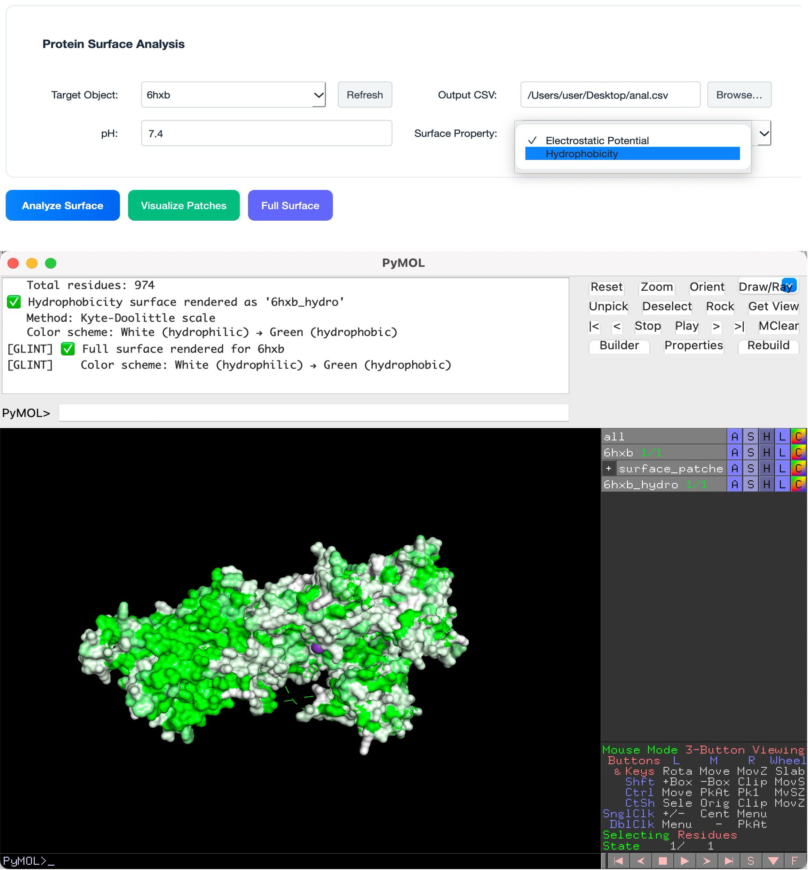
Figure 4. Protein surface hydrophobicity analysis using GLINT.
The top panel shows the Protein Surface Analysis interface with hydrophobicity selected as the surface property (pH = 7.4). The middle panel displays the PyMOL log output confirming successful surface rendering using the Kyte–Doolittle scale. The bottom panel presents the protein surface visualization, where hydrophobic regions are highlighted in green and hydrophilic regions in white, revealing potential ligand-binding sites and functional surface patches.

2.3 Surface Similarity & Complementarity
This module provides a comprehensive framework for comparing geometric and chemical features across two protein surfaces. It supports both similarity and complementarity analyses. In similarity search, the module identifies regions on a target surface that closely resemble a given template, enabling the detection of structurally or chemically conserved patterns. In complementarity search, it focuses on finding regions that are structurally and chemically compatible with the template surface, which is particularly useful for predicting protein–protein interaction (PPI) interfaces.
2.3.1 Workflow
Select Objects:
- Object 1: template protein (with known functional surface)
- Object 2: target protein
Define Template Region:
Source | Description
Ligand Pocket | Automatically constructs pocket around ligand (recommended)
Custom Region | Manually defined region
Ligand Pocket Parameters:
Parameter | Default | Description
Pocket Ligand | organic | Ligand selection expression
Pocket Radius (Å) | 6.0 | Radius around ligand
Analysis Parameters:
Parameter | Default | Description
Surface Method | auto | auto / open3d / edtsurf
Patch Radius (Å) | 12.0 | Surface patch size
Interface Dist (Å) | 4.0 | Contact distance threshold
Run Analysis:
- Run Similarity Search
- Run Complementarity Search
Visualize Results: Click Show Matched Regions
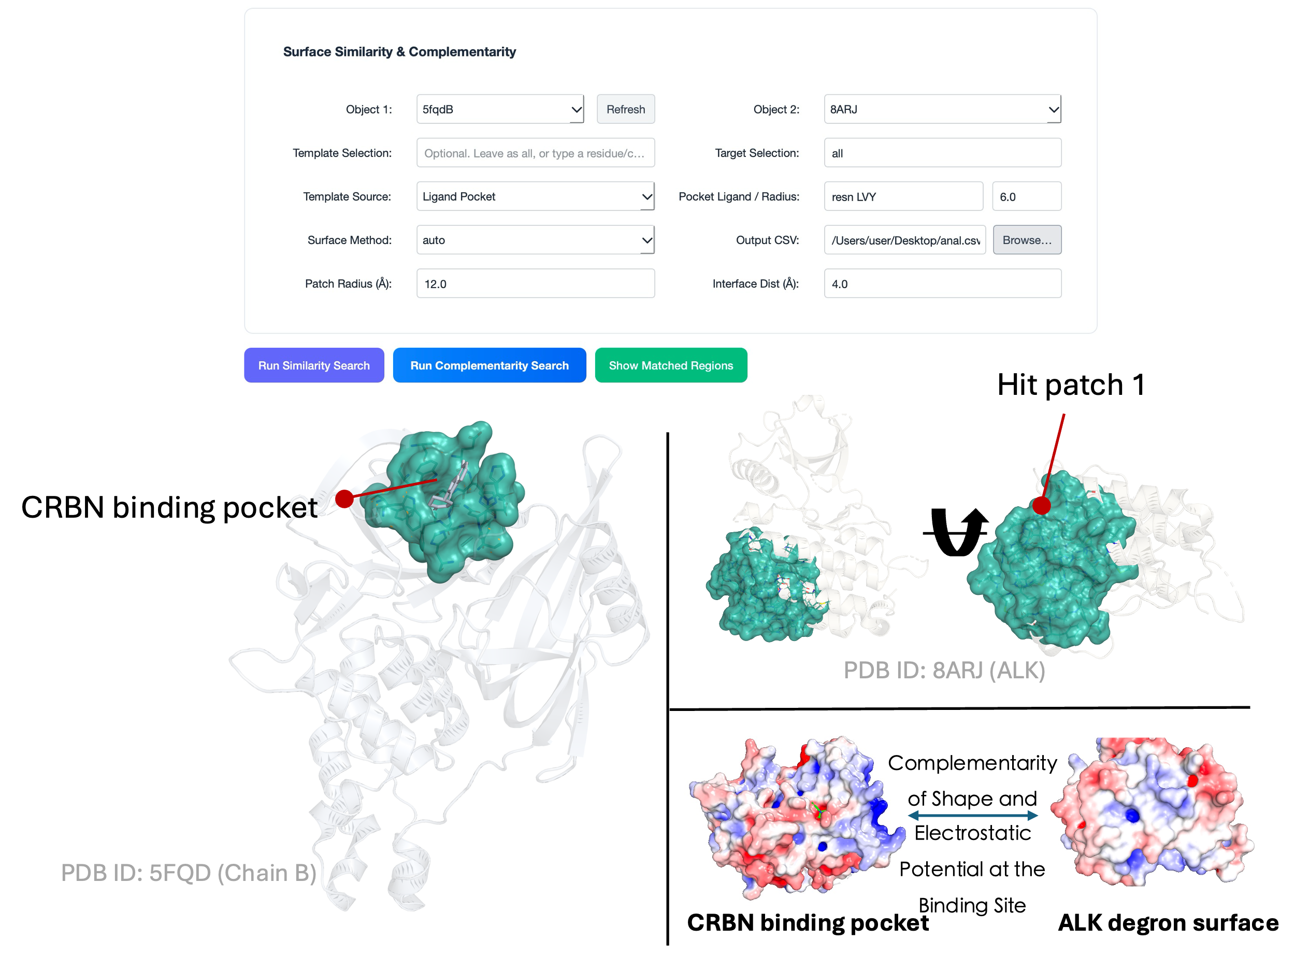
Figure 5. Surface complementarity analysis using GLINT.
The top panel shows the Surface Complementarity interface with parameters configured for ligand pocket–based analysis (Object 1: 5FQD, Object 2: 8ARJ). The left panel illustrates the template binding pocket automatically defined around the ligand (cyan surface) on the reference protein (PDB ID: 5FQD, chain B). The right panel shows matched surface patches identified on the target protein (PDB ID: 8ARJ), highlighting structurally similar regions. The bottom panel presents electrostatic surface representations of the matched regions, where red and blue indicate negative and positive potentials, respectively, demonstrating physicochemical complementarity between the template and target surfaces.

Chapter 3 Hit Identification
The Hit Identification module is a core functional component of the GLINT framework for candidate molecule modeling and screening. It integrates two key tools—AutoDock Vina for small-molecule docking and HADDOCK3 for protein–protein docking—forming a continuous workflow from ligand pose prediction to ternary complex modeling.

3.1 AutoDock Vina Small-Molecule Docking
Evaluate the binding affinity between candidate small-molecule ligands and target proteins, and predict binding poses.
Workflow
Receptor Selection:
Load the target protein structure in PyMOL and select the object to be used as the receptor.
Ligand Input:
- Single-ligand docking:
Select a single ligand file (supported formats: .pdbqt, .sdf, .mol2)
- Batch docking:
Select a folder containing multiple ligand files; the system will automatically iterate through all ligands and perform batch docking
Docking Box Definition:
- Center selection:
Automatically calculate the geometric center based on a PyMOL selection
- Manual input:
Directly specify the center coordinates (X, Y, Z) and box dimensions
Parameter Settings:
- exhaustiveness (search thoroughness):
Range: 1–32 (default: 8). Higher values increase search accuracy but require more computation time
- num_modes (number of output poses):
Range: 1–20. Controls the number of top-ranked binding poses returned
Run Docking:
Click “Run Docking”. The system will automatically perform format conversion, docking calculations, and result parsing.

3.2 HADDOCK3 Protein–Protein Docking
Use Case:
Build structural models of E3 ligase–molecular glue–substrate ternary complexes based on known ligand binding poses.
Workflow
Receptor and Ligand Selection:
Select two protein objects in PyMOL as the receptor and ligand for docking.
Residue Restraint Definition:
- Active residues:
Key residues involved in molecular glue–mediated interface formation
- Passive residues:
Residues allowed to participate in contacts but not driving the interaction
Restraint File Generation:
The system automatically generates an AMBIG.tbl restraint file, using either the haddock3-restraints CLI or a built-in fallback method.
Configuration Generation and Execution:
A minimal HADDOCK3 configuration file is automatically generated, including the following stages:
[topoaa] # Topology building
[rigidbody] # Rigid-body sampling (default: 60 structures)
[flexref] # Flexible refinement
[emref] # Energy minimization refinement
Model Collection and Loading:
After computation, output models are collected based on priority (emref > flexref > rigidbody), merged into a multi-model PDB file, and loaded into PyMOL.
Scoring Extraction:
The system automatically parses capri_ss.tsv or capri_clt.tsv files to extract HADDOCK scores for downstream analysis.
Alternative Options:
If HADDOCK3 is not installed locally:
- Click “Open HADDOCK Server” to access the HADDOCK web server
- Use “Export PDB for Server” to export structure files for online submission

3.3 Typical Workflow Example
Ligand Library → Vina Batch Docking → Top-N Pose Selection → HADDOCK3 Ternary Complex Modeling → Candidate Optimization

Step-by-Step Description
- Batch Docking with Vina:
Perform batch docking on a candidate ligand library using AutoDock Vina.
Select hit molecules with binding affinity < −7 kcal/mol (E3–MG complexes).
- Prepare Docking Inputs for HADDOCK3:
Import the selected E3–molecular glue (E3–MG) complexes together with the target protein structure into HADDOCK3.
Define residues surrounding the molecular glue as active restraints.
- Ternary Complex Modeling:
Perform restraint-driven docking to construct E3–MG–target protein ternary complexes, generating multiple candidate conformations for further evaluation.
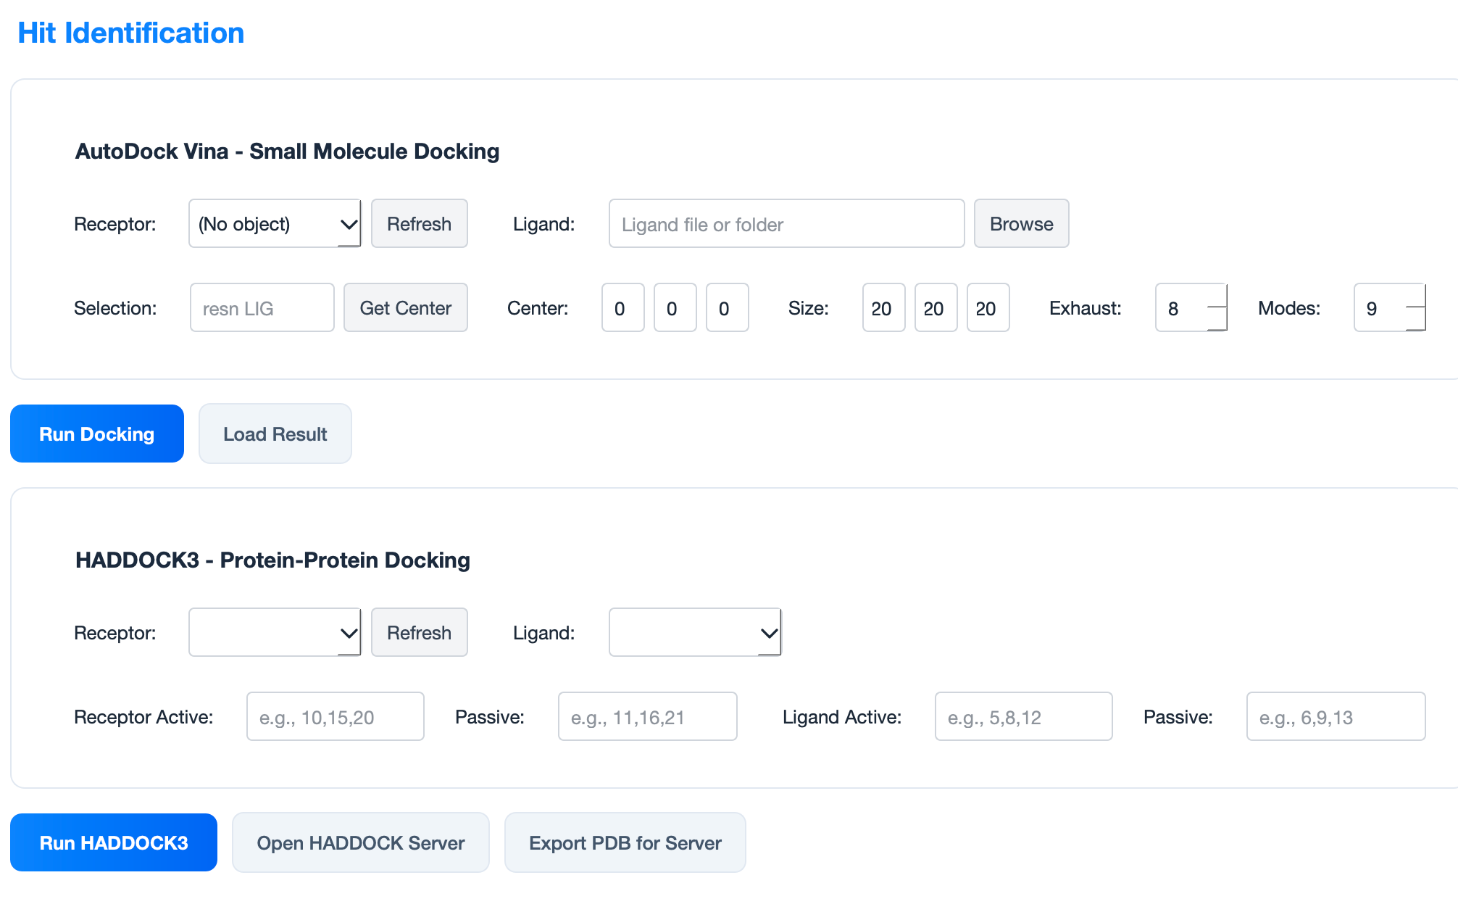
Figure 6. Hit Identification module in GLINT.
The interface integrates two core components for candidate modeling and screening. The top panel shows the AutoDock Vina workflow for small-molecule docking, including receptor selection, ligand input, docking box definition, and parameter settings (center, size, exhaustiveness, and number of modes). The bottom panel presents the HADDOCK3 protein–protein docking setup, where receptor and ligand proteins are selected and active/passive residue restraints are defined. Together, these tools enable a streamlined workflow from ligand docking to ternary complex modeling.

Chapter 4 Ternary Evaluation
The Ternary Complex Evaluation module is one of the core components of GLINT, specifically designed to analyze interactions between E3 ubiquitin ligases and target proteins (POIs) mediated by molecular glues. This module integrates three major computational components—Interface Analysis, Ligand Properties, and Ternary Geometry—to provide a comprehensive structural assessment of ternary complexes.
Interface Module
The Interface Module focuses on calculating Buried Surface Area (BSA) and contact atom statistics. A dedicated formulation for ternary complexes is used:
$${\text{BSA}}_{MG}=\left(SA_{E3-MG}+SA_{POI-MG}\right)-SA_{E3-POI-MG}$$
where SA_{E3-MG} and SA_{POI-MG} represent the surface areas of the E3–ligand and POI–ligand binary complexes, respectively, and SA_{E3-POI-MG} corresponds to the total surface area of the full ternary complex.
Surface area calculations are performed using PyMOL’s get_area() function, with FreeSASA as an alternative for ligand surface calculations. In addition to BSA, the module computes:
- Contact atom counts within 4.5 Å and 5.0 Å cutoffs
- Minimum interatomic distances between components
These metrics provide quantitative indicators for evaluating binding strength and specificity of molecular glues.
Ligand Module
The Ligand Module evaluates physicochemical properties of small-molecule ligands using the RDKit library. Based on the ligand’s SMILES representation, the module calculates:
- Molecular weight (MW)
- LogP
- Topological polar surface area (TPSA)
- Hydrogen bond donors and acceptors (HBD/HBA)
- Number of rotatable bonds
- Fsp³ ratio
- Ring count
These descriptors are essential for assessing drug-likeness and understanding the ligand’s role within the ternary complex.
If a SMILES string cannot be directly extracted, the system attempts to reconstruct it from the ligand structure using Open Babel or RDKit.
The Ternary Geometry Module analyzes spatial relationships within the complex. Two key geometric descriptors are computed:
- COG Shift:
The perpendicular distance of the ligand’s center of geometry (COG) from the E3–POI axis, reflecting how far the ligand deviates from the interface axis
- E3–MG–POI Angle:
The angle formed by the three components, describing their relative spatial arrangement
Additionally, the module calculates:
- Centers of geometry for each component
- Minimum interatomic distances between components
These parameters provide detailed insights into the structural organization of the ternary complex.
The module introduces a Balance Index (also referred to as the Duality Index) to evaluate binding symmetry:
$$\text{Balance Index}=\frac{\min\left(BSA_{MG-E3},BSA_{MG-POI}\right)}{\max\left(BSA_{MG-E3},BSA_{MG-POI}\right)}$$
This metric ranges from 0 to 1:
- Values close to 1.0 indicate balanced binding between E3 and POI
- Values close to 0.0 indicate asymmetric binding toward one side
This index is particularly useful for assessing the “molecular glue” behavior, where ideal candidates exhibit balanced interactions with both proteins.
The module features a modern, card-based interface, including:
- Input panel: selection of PyMOL object, E3 chain, POI chain, and ligand residue
- Three analysis panels: Interface, Ligand, and Geometry
- Summary panel and detailed results view
Users can:
- Run a full evaluation via “Run Full Evaluation”
- Execute individual modules separately
- Export results as CSV
- Visualize geometric features directly in PyMOL
The system performs computations using multithreading, with results displayed upon completion.
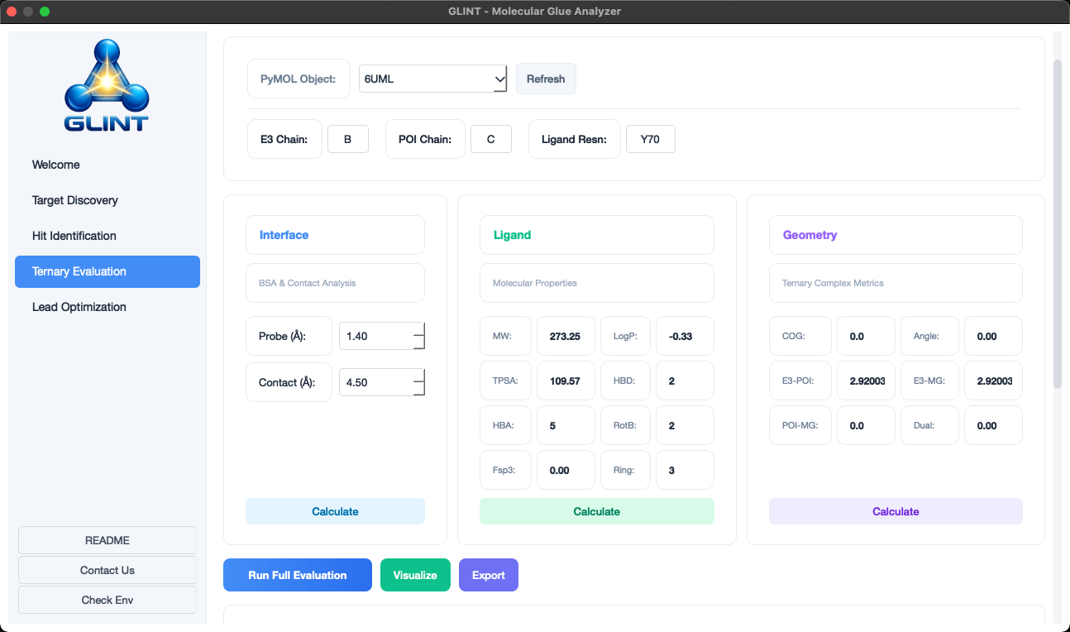
Figure 6. Ternary Evaluation module in GLINT.
The interface provides integrated analysis of E3 ligase–molecular glue–target protein ternary complexes. The top panel allows selection of the PyMOL object, E3 chain, POI chain, and ligand residue. The lower panels display three analysis components: Interface (buried surface area and contact analysis), Ligand (molecular properties such as molecular weight, LogP, TPSA, and hydrogen bonding features), and Geometry (ternary complex metrics including distances, angles, and shape complementarity). Results can be computed and visualized, enabling quantitative evaluation of ternary complex stability and quality.

Chapter 5 Lead optimization
The Lead Optimization module is a core component of the GLINT toolkit, designed to provide medicinal chemists and structural biologists with a comprehensive suite of molecular interaction analysis tools. This module integrates four key analysis approaches—electrostatic complementarity, protein–protein interface analysis, protein–ligand interaction analysis, and ligand–ligand interaction analysis—offering multi-perspective guidance for structure-based drug design and optimization.

5.1 Electrostatic Complementarity (EC) Analysis
The Electrostatic Complementarity (EC) module is one of the central tools for lead optimization, used to evaluate the electrostatic matching between a ligand and its protein binding site. This module is based on electrostatic potentials computed using APBS (Adaptive Poisson–Boltzmann Solver).
The workflow follows a rigorous computational pipeline:
- Structure preprocessing:
Protein structures are processed using PDB2PQR, including hydrogen addition, protonation state optimization, and charge assignment
- Electrostatic calculation:
APBS is used to compute the 3D electrostatic potential field of the protein, generating OpenDX grid data
- Ligand surface sampling:
The ligand solvent-accessible surface is generated using van der Waals radii, followed by dense surface sampling
- Complementarity calculation:
At each sampled surface point, the EC index is computed as the product of protein and ligand electrostatic potentials
- Positive EC values: electrostatic complementarity (attractive interactions)
- Negative EC values: electrostatic repulsion
Advanced features include:
- σ-hole virtual site generation (for halogen bonding)
- Lone pair virtual sites (e.g., carbonyl oxygen)
- Bridging water molecule filtering
These enhancements improve both the accuracy and biological relevance of EC analysis.

5.2 Protein–Protein Interface (PPI) Analysis
The Protein–Protein Interface (PPI) module is designed to characterize interactions within protein complexes. It identifies and analyzes interface regions between two proteins, including:
- Interface residue identification
- Contact residue counts and types
- Interface surface area and interaction strength
Users can specify:
- Chain IDs (e.g., A and B)
- Distance cutoff (default: 4.5 Å)
The module supports multiple visualization modes:
- Surface + interaction representation
- Cartoon + interaction representation
Optional display features include residue labels, distance labels, and hydrophobic interactions.
Interface strength is evaluated based on contact counts, interface area, and interaction diversity, providing quantitative insight into complex stability.

5.3 Protein–Ligand Interaction Analysis
The Protein–Ligand Interaction module is one of the most widely used tools for lead optimization. It provides detailed characterization of interactions between small molecules and protein targets.
The system supports automatic ligand detection or manual specification and identifies multiple interaction types:
- Hydrogen bonds
- Salt bridges
- π–π stacking
- Cation–π interactions
- Hydrophobic interactions
- Halogen bonds
- Metal coordination
Interactions are detected using geometry-based rules combined with confidence scoring to ensure reliability.
Users can:
- Set a minimum confidence threshold (default: 0.8)
- Toggle hydrophobic interactions and distance labels
Visualization options include:
- 3D visualization in PyMOL
- 2D interaction diagrams, generated with ligand structures and annotated interactions for reporting and presentation

5.4 Ligand–Ligand Interaction Analysis
The Ligand–Ligand Interaction module analyzes interactions between two small molecules. It is particularly useful for:
- Drug–drug interaction analysis
- Covalent inhibitor reaction modeling
- Ligand dimerization studies
Users define ligand selections using PyMOL syntax (e.g., resn LIG1 and resn LIG2). The system then:
- Counts contacting atoms
- Measures interatomic distances
- Identifies potential hydrogen bonds and π–π interactions
In molecular glue–based degrader design, this module helps evaluate interaction balance between:
- Molecular glue and E3 ligase
- Molecular glue and target protein

